**DBMS Assignment-4**

**Riya Chaudhary**

**17070122056**

**CS3**

1. Cheapest book of SIBM library:

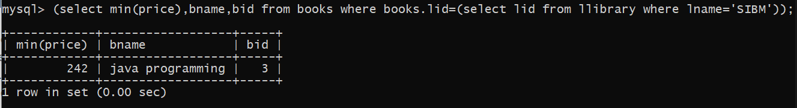

1. Library with costliest book

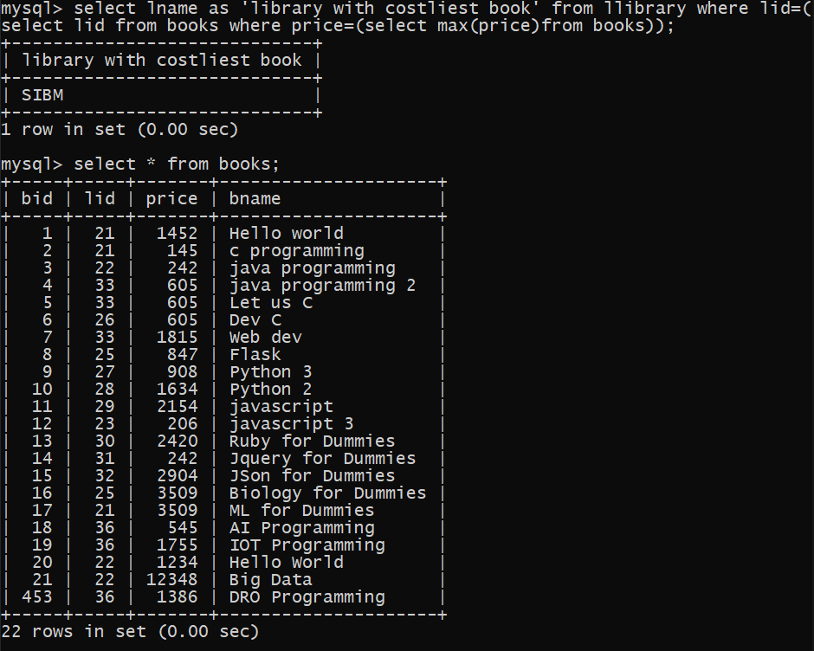

1. Number of sit students issuing books

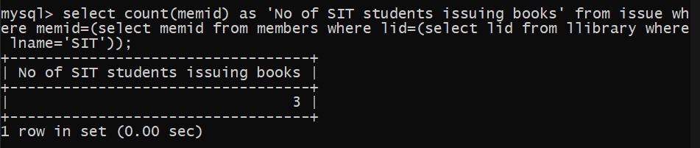

1. Average price of books of SITM

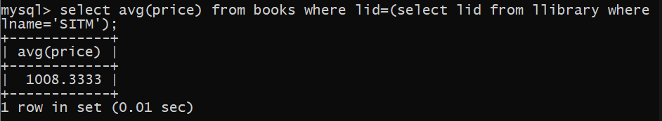

1. Total cost of books purchased by SSBS in jan

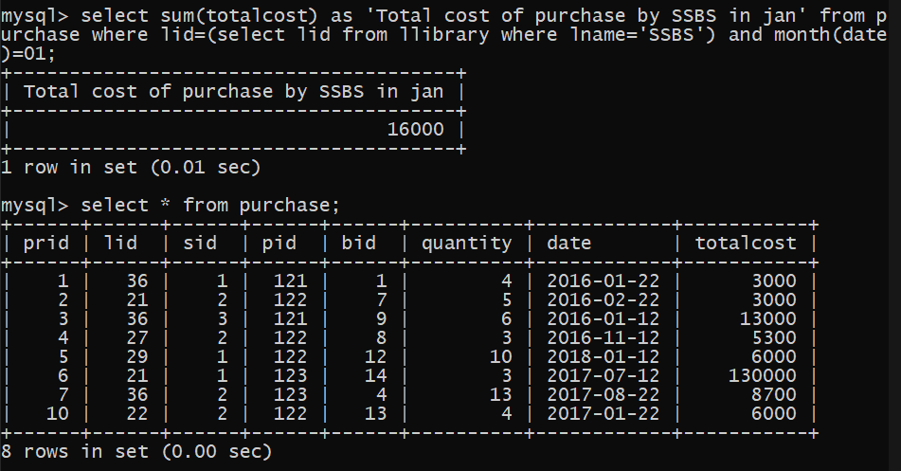

1. Number of books written by shruti

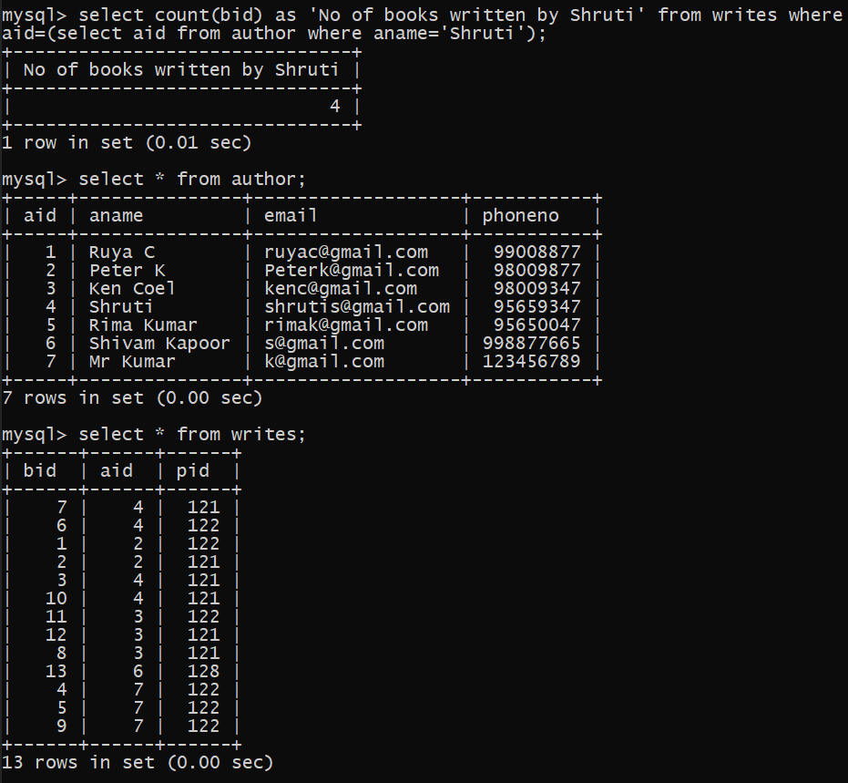

1. Costliest book published by “Pragati Book Store

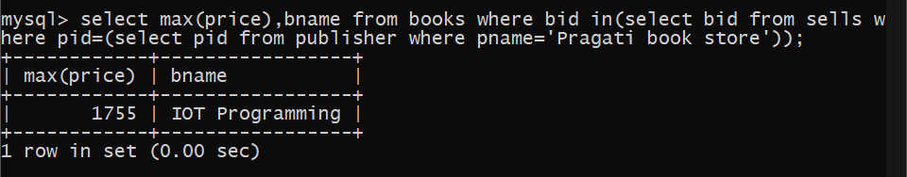

1. Total copies of books by SIT

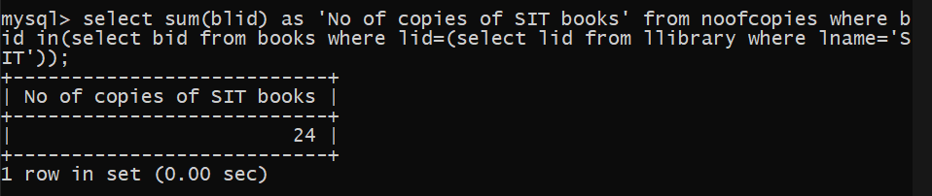

1. Average cost of books by Mr Kumar

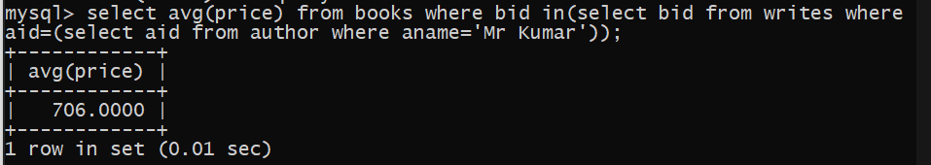

1. Books sold by seller in Nagpur

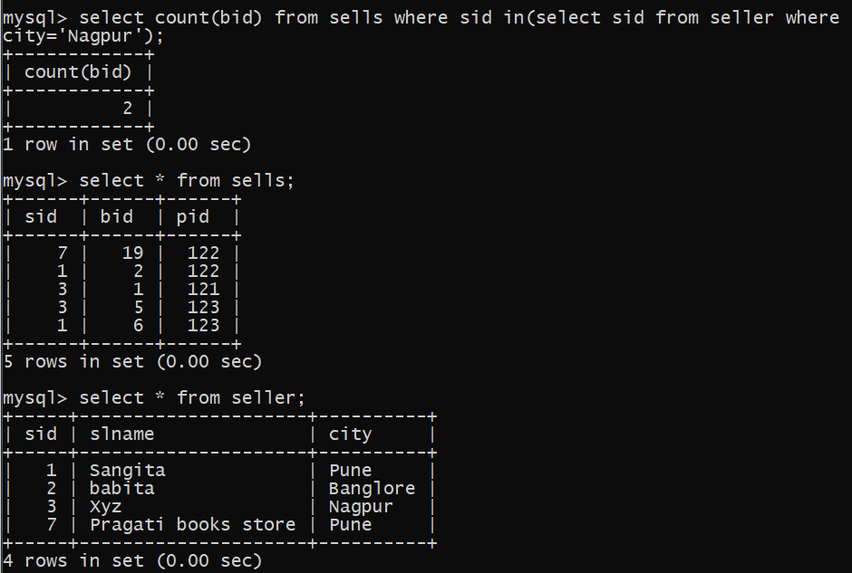

1. Print SSBS student name in capital

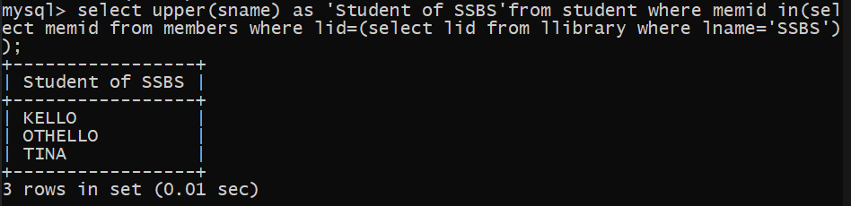 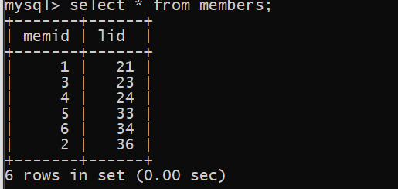 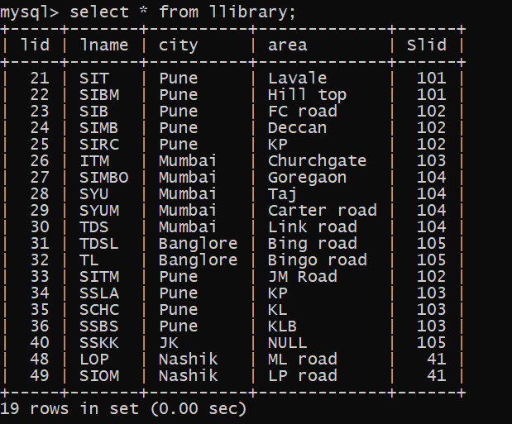

1. Add two months to issue date of book written by ‘Ameya’

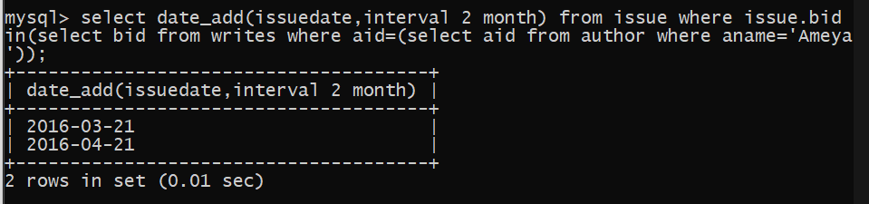

1. Last day of month when Ayush issued book

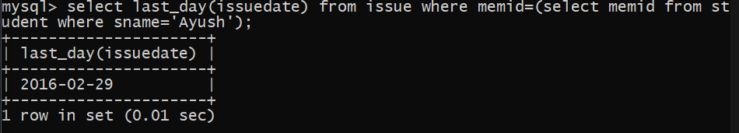

1. How many books are issued from January to march 2016

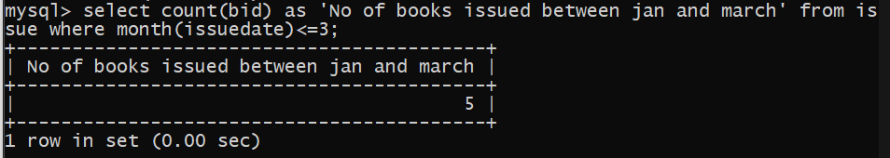

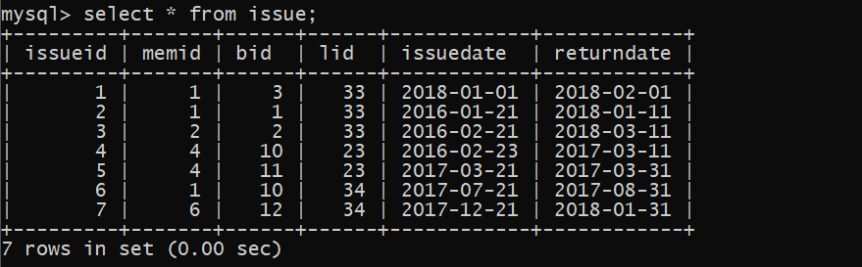

1. How many books have copies less than 5 in SIBM

